**Assignment 1:** Draw your Home Network Topology and explain how you are accessing the RPS Lab environment

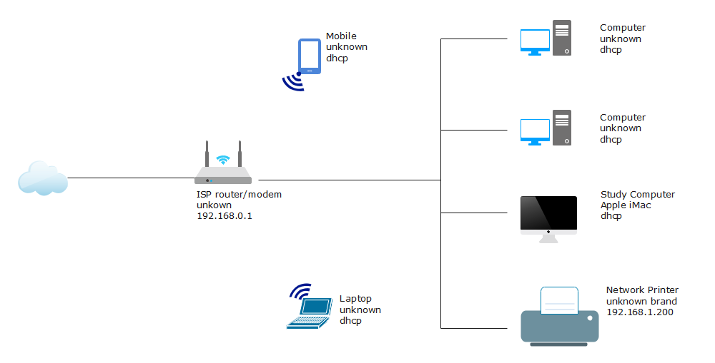

The above drawing represents a Star Topology of my Home Network.

1. **Components in the Diagram:**

**Internet (cloud):**

* Represents the global network that connects everyone.
* Wi-Fi Router:
* Acts as the central hub that connects all devices like laptop, mobile, etc.,
* Devices:
* Includes a laptop, smartphone and tablet connected to the Wi-Fi router.

1. **How it Works:**
2. The Wi-Fi router connects to the Internet Cloud via my Internet Service Provider (ISP).
3. The ISP provides a wired or wireless connection to the router.
4. All devices act as the “middleman” for sending and receiving the data.
5. **When I open a website or app:**
6. The request goes from my devices to the router.
7. The router forwards the request to the internet.
8. The internet sends the data back to the router, which delivers it to your device
9. Local Access (When You Are in the Lab)

• Wired Connection:

Connect your computer to the network using a cable (Ethernet). Example: The PCs (like PC1, PC2) in the diagram are connected to the switches using cables.

• Wireless Connection:

Connect to the Wi-Fi provided by the lab's wireless router.

Example: Laptops (Laptop 1, Laptop 2) in the diagram are connected through Wi-Fi.

1. Web Access (Through a Browser)

Some labs allow access through a website or portal.

• Just open your browser, log in to the lab’s portal, and use the tools or software provided.

• Example: Cloud-based labs or admin dashboards.